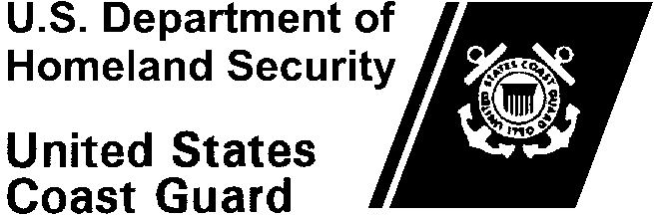Commandant

United States Coast Guard XXXXXXX

XXXXX XXXXXXXX

Phone: (XXX) XXX-XXXX

Email: [XXXXX@uscg.mil](mailto:XXXXX@uscg.mil)

# XXXXX

Month Day, 2022

MEMORANDUM

From: (Name, Command, Directorate, etc.)

# To: CG-124

Thru: *(Flag/SES level endorsement)*

Subj: NOMINATION FOR 2021 CIVILIAN EMPLOYEE OF THE YEARFOR

(Nominee Name)

# Please check one:

GS-9 or FWS-9 and below

GS-10 thru GS-13 or FWS-10 thru FWS-13

GS-14 or FWS-14 and above

Ref: (a) Coast Guard Civilian Awards Manual, COMDTINST M12451.1 (Series), Chapter 5

(b) ALCOAST XXX/22

1. I hereby nominate *(nominee name, title, series, grade and command),* for the 2021 Civilian Employee of the Year. *(Include a sentence showing eligibility requirements have been met, i.e., civilian service with U.S. Coast Guard and performance rating for previous evaluation period).*
2. (Brief statement of current duties.)
3. (Brief biographical employment history)
4. (A listing of significant honors and awards received within the last 2-year period).
5. (Narrative showing clearly how all criteria for the award has been met with specific facts and examples.)

**- Document may not exceed two pages -**

Enclosure: Coast Guard Award Recommendation, Form CG-1650